FitLife Solutions Design Document

Task Design

System overview
FitLife Solutions requires a system designed to provide personalised fitness and wellness support for every client. The system will allow each user to log in securely, with their information stored in Tbl_user, which keeps all essential account and profile data. After logging in, users will be able to access their fitness tracker, which will record all workout sessions within Tbl_user_workouts, including exercise type, duration, and performance details. The system will also generate visual progress reports using data from Tbl_user_progress, allowing clients to view charts that track improvements over time. To assist in recommending suitable workouts, the platform will include Tbl_workouts, a library of structured routines that the algorithm can use to assign the most appropriate exercises based on user goals and previous activity.
The system will additionally support personalised nutrition planning through Tbl_food, which stores information about meals, ingredients, nutritional values, and dietary requirements. This allows the platform to generate tailored food plans that match the user’s needs and preferences. FitLife Solutions will also include a rich content section powered by Tbl_videos, which will hold recordings of fitness activities such as cycling, running, HIIT sessions, relaxation routines, and mental‑health‑focused content. These videos will be available for users to view as part of their fitness and wellness journey. All core features—including workout tracking, progress graphs, personalised meal plans, and access to the video library—will only be accessible to clients with a premium subscription, ensuring a complete and enhanced fitness experience for subscribed users

Inputs identified
Input name | Data types | Entered by | Purpose
Username | Varchar(50) | Client | To allow the user to access their unique account
Password | Varchar(100) | Client | Final stage of authentication to log in
Workout entry: time, activity, calories | Time: date/time  Activity: String  Calories: Integer | Client | To store activity of the user in the Tbl_activity to analyse later
Dietary preferences | String | User | Allows the system to generate suitable meal plans using data from Tbl_food
Wellness content selection | Boolean | User | Records which videos or sessions a user accesses from Tbl_videos
User inputs are essential as they allow the system to personalise the experience. Login details ensure that only authorised users can access personal fitness and wellness data. Workout details are required so the system can track progress and display meaningful feedback to the user. Dietary preferences are used by the meal planner to ensure meal plans are suitable for individual needs, while wellness content selection helps users engage with mental health and wellbeing resources relevant to them.

System‑Generated Inputs
Input Name | Data Type | Entered By | Purpose
Progress metrics | Integer / Decimal | System | Automatically calculated from workout data and stored in Tbl_user_progress
Exercise recommendations | String | System | Generated using predefined routines from Tbl_workouts based on user activity
Usage history | Integer | System | Records how often features are accessed to support engagement tracking
System‑generated inputs are created automatically using existing data within the database. Progress metrics allow the system to present visual graphs that show improvement over time, helping to motivate users. Exercise recommendations are generated based on stored workout routines and user activity, supporting personalised fitness plans. Usage history helps monitor engagement, which aligns with the client’s objective of increasing regular interaction with the platform.

Staff / Admin Inputs
Input Name | Data Type | Entered By | Purpose
Client profile updates | String | Staff | Allows staff to update user settings in Tbl_user when required
Workout routine data | String | Staff | Maintains predefined workouts stored in Tbl_workouts
Wellness content uploads | File / String | Admin | Adds or updates video content stored in Tbl_videos
Staff and admin inputs ensure that the system remains accurate and up to date. Staff may need to update client settings to reflect changes in fitness plans, while administrators manage workout routines and wellness content. This ensures that users always have access to relevant and current resources, supporting the overall quality of the service.

Client objectives
These inputs work together to support FitLife Solutions’ objectives by enabling personalised fitness tracking, interactive meal planning, and accessible mental health resources. User‑entered data allows personalisation, system‑generated data provides feedback and recommendations, and staff inputs ensure the content remains accurate and relevant, resulting in a well‑maintained and engaging digital solution.

Processes Identified
The system operates through a series of logical processes that ensure data is handled securely, accurately, and efficiently. Each process uses defined inputs, performs a clear action, and produces a meaningful output for the user or the system.

Authentication Process
The system first processes the user’s login details entered through the login interface.
This ensures that only authorised users can access the system and that personal fitness and wellness data remains secure.
Once validated, the system proceeds to check the entered credentials against stored records. The data is then retrieved from Tbl_user, and if the details match, access is granted and the user is directed to their personalised dashboard.
- Inputs used: User login details
- Output produced: Successful login or access denied message

Data Validation Process
The system first processes user‑entered data such as workout details or dietary preferences. This ensures that the data is complete, in the correct format, and suitable for storage. Once validated, the system proceeds to prepare the data for saving or further processing. The data is then either stored in the relevant table, such as Tbl_user_workouts, or used to generate system outputs like recommendations.
- Inputs used: Workout details, dietary preferences
- Output produced: Validated data ready for storage or processing

Record Creation Process
The system first processes validated user inputs when a new activity is logged. This ensures that each workout or preference entry is accurately recorded for future use. Once validated, the system proceeds to create a new record linked to the user’s account. The data is then stored in Tbl_user_workouts or Tbl_user_progress, allowing progress to be tracked over time.
- Inputs used: Validated workout data
- Output produced: New database record linked to the user

Record Update Process
The system first processes updated information, such as changes to user settings made by staff. This ensures that existing records remain accurate and up to date. Once validated, the system proceeds to modify the relevant stored data. The data is then updated in Tbl_user, ensuring the user profile reflects the latest information.
- Inputs used: Client profile updates
- Output produced: Updated user record

Data Retrieval Process
The system first processes a request for information, such as viewing progress or accessing wellness content. This ensures the correct data is retrieved for the correct user. Once validated, the system proceeds to fetch the relevant records.
The data is then retrieved from tables such as Tbl_user_progress or Tbl_videos and displayed to the user in a clear and accessible format.
- Inputs used: User request (e.g. view progress, watch video)
- Output produced: Displayed progress graphs or wellness content

Link to Client Objectives
These processes work together to support FitLife Solutions’ objectives by enabling secure access, accurate tracking of fitness data, and easy retrieval of personalised content. Authentication protects user data, record creation and updates support personalised fitness tracking, and data retrieval ensures users can easily access fitness, nutrition, and mental wellbeing resources, increasing engagement with the platform.

Outputs identified
Output | Triggered by | Displayed to | Purpose
User logged in message | User submitting username and password | User | To let the user know that they have gained access to the system
User workout log | User uploading their workouts | User | Tells them what they have logged exercise wise showing data such as calories, workout name and time of activity
Personalised user dashboard | User logging in successfully | User | Provides overview over a period of time, on each activity and graph information and progress metrics and log in history
Updated dietary requirements | User entering their dietary requirements | User | To let the user know what they have selected and inform what food they have as a recommendation
Exercise recommendations | Completion of workout logging | User | Suggests suitable exercises based on stored routines and user activity
Wellness video content | User selecting a workshop or video | User | Provides access to mental health and wellbeing resources
Profile update confirmation | Staff updating client details | Staff | Confirms that changes to user records have been saves successfully
Workout progress graphs | User viewing progress data | User | Visually displays progress of fitness progress, meal plans, and wellness content

Main flowchart
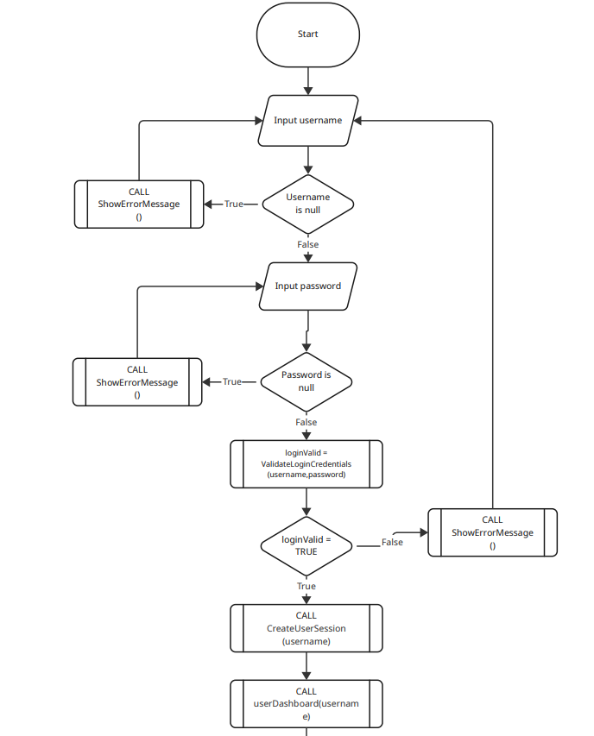
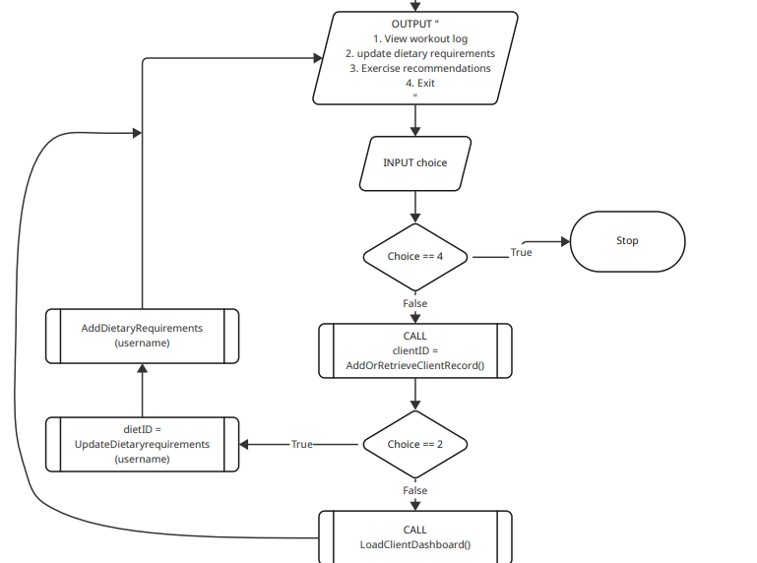
This flowchart represents the secure entry point to the FitLife system. Corporate clients must log in before they can view the workout log, update dietary requirements or look at exercise recommendations. Login ensures this is linked to the correct client account, which supports accurate communication, and improved customer satisfaction

Pseudocode Section

Subroutine to Validate Login Credentials
FUNCTION ValidateLoginCredentials (username, password)
BEGIN FUNCTION
SET loginValid TO FALSE
#Retrieve password hash for the given username from Tbl_User
SET storedPasswordHash TO SELECT password_hash FROM Tbl_User WHERE username = username

#Log the login attempt for audit purposes
WRITE Tbl_LoginAudit username, CURRENT_TIME, “Attempt”

IF storedPasswordHash <> “” THEN
IF VerifyPassword(password, storedPasswordHash) = TRUE THEN
SET loginValid TO TRUE

#Log successful login
WRITE Tbl_LoginAudit username, CURRENT_TIME, “Success”
ELSE
#Log failed password verification
WRITE Tbl_LoginAudit username, CURRENT_TIME, “FailedPassword”
END IF
ELSE
#Log failed email lookup
WRITE Tbl_LoginAudit username, CURRENT_TIME, “FailedEmail”
END IF
RETURN loginValid
END FUNCTION

Subroutine to Create User Session
FUNCTION CreateUserSession (username)
BEGIN FUNCTION

DECLARE sessionLoggedIn AS BOOLEAN
DECLARE sessionUser AS STRING
DECLARE sessionStartTime AS DATE/TIME
DECLARE sessionExpiryTime AS DATE/TIME

SET sessionUser TO username
SET sessionLoggedIn TO TRUE
SET sessionStartTime TO CURRENT_TIME
SET sessionExpiryTime TO sessionStartTime + 2 HOURS

# Log session creation for audit
SEND “session created for: “ & sessionUser & ” at “ & sessionStartTime TO DISPLAY

# Store session details in session table
WRITE Tbl_Session sessionUser, sessionStartTime, sessionExpiryTime, sessionLoggedIn

Return sessionLoggedin
END FUNCTION

Subroutine to Load Client Dashboard
FUNCTION LoadClientDashboard ()
BEGIN FUNCTION

SEND “Dashboard loaded” TO DISPLAY
SEND “Welcome, corporate client!” TO DISPLAY

# Display main dashboard options
SEND “Options:” TO DISPLAY
SEND “1. View workout log” TO DISPLAY
SEND “2. Update dietary requirements” TO DISPLAY
SEND “3. Exercise recommendations” TO DISPLAY
SEND “4. Exit” TO DISPLAY

# Show summary of recent activity
SEND “View workout log:” TO DISPLAY
# Assume ViewWorkoutLog() returns a list of recent workouts
FOR EACH workout FROM ViewWorkoutLog(username) DO
SEND workout TO DISPLAY
END FOREACH
# Show exercise recommendations
SEND “Exercise recommendations:” TO DISPLAY
FOR EACH exercise from exerciseRecommendations (username) DO
SEND “exercise ID:” & exerciseRecommendations.exerciseID & “exercise: ” & exerciserecommendations.exercise TO DISPLAY
END FOREACH

END FUNCTION

Subroutine to show error message
FUNCTION ShowErrorMessage(errorType)
BEGIN FUNCTION

IF errorType = “Missing username” THEN
SEND “Enter your username” TO DISPLAY
ELSE IF errorType = “Missing password” THEN
SEND “Enter your password” TO DISPLAY
ELSE IF errorType = “Invalid login” THEN
SEND “Login failed. Check your details and try again” TO DISPLAY
ELSE
SEND “An error occurred. Please contact support if the problem continues” TO DISPLAY
END IF

# Log the error for audit and support
WRITE Tbl_ErrorLog errorType, CURRENT/TIME
END FUNCTION

Subroutine to update a dietary requirement
FUNCTION UpdateDietaryRequirement(username, dietID)
BEGIN FUNCTION

DECLARE username AS STRING
DECLARE dietID AS INTEGER

SET username TO SELECT diet_ID FROM Tbl_client WHERE

Variable list
Variable Name | Data Type | Description | Used in
Username | STRING | Stores username entered by client | Main flowchart
Password | VARCHAR(50) | Stores login password entered by client | Main flowchart
loginValid | BOOLEAN | Indicates if login credentials are valid | ValidateLoginCredentials
dietID | INTEGER | Unique identifier for diet | Main flowchart
sessionUser | STRING | SessionUser allows client to use website under their username | Subrouting to create user session
The variable list defines the key data items required for the FitLife Solutions digital platform. Input variables such as Username and Password store the login details entered by clients when accessing personalised fitness plans, meal planning tools, and wellness resources. Processing variables such as loginValid, dietID, and sessionUser support the platform’s internal logic, loginValid confirms whether the user’s credentials are correct, dietID identifies the client’s selected dietary preference for use in personalised meal plans, and sessionUser maintains an active session so the client can securely navigate fitness tracking and wellness features. Clearly defining variable names, data types, and their purpose ensures consistent logic across the system, supports accurate data handling, and aligns directly with the project requirements for secure authentication, interactive meal planning, and personalised fitness and wellness tools.

Error handling plan
Error Type | Where occurs | System Action | User Feedback
Missing username | Login | Stop Validation | “Please enter username”
Missing password | Login | Stop Validation | “Please enter password”
Invalid credentials | Login | Deny access | “Login Failed. Try again”
Network/supabase error | Any DB call | Retry option | “Connection error. Try again”
The error handling plan ensures that the FitLife Solutions digital platform responds consistently and professionally whenever users provide incorrect information or when system operations fail. During the login process, validation checks detect issues such as a missing username or missing password, and the system immediately stops validation and provides clear prompts such as “Please enter username” or “Please enter password”. If the user enters invalid credentials, the system denies access and returns the message “Login Failed. Try again”, helping protect secure access to personalised fitness plans, meal-planning tools, and wellness resources.
Beyond login, the platform must remain reliable during all database-dependent actions, such as saving workout logs, loading customised meal plans, or updating wellness session progress. If a network or Supabase connection error occurs during any database call, the system activates a retry option and informs the user with “Connection error. Try again”. This prevents data loss while keeping users aware of temporary issues.
By anticipating these failure points and defining clear system responses, the error-handling strategy supports the FitLife Solutions project objectives—maintaining accessibility, improving user experience across personalised fitness and nutrition features, and ensuring users can securely track their health and wellness activities without interruption.

Normalisation
The dataset provided represents FitLife Solutions’ current user wellness records stored in a single, unstructured table. It mixes information about users, fitness activities, dietary preferences, meal plans, and wellness sessions all in one place. This unnormalised structure contains repeated groups and non-atomic values, making it inefficient and increasing the risk of inconsistent or duplicated health and fitness data. To improve the system and support the platform’s personalised fitness, nutrition, and wellness features, a structured normalisation process will be applied.
First, the data will be converted from Unnormalised Form (UNF) to First Normal Form (1NF) by ensuring all values—such as workouts, meal items, or session entries—are stored atomically. Next, the design will move to Second Normal Form (2NF) by removing partial dependencies and separating data into appropriate entities, such as Users, FitnessLogs, MealPlans, Diets, and WellnessSessions. Finally, Third Normal Form (3NF) will be achieved by eliminating transitive dependencies so each table stores information about one concept only.
By restructuring the dataset into a fully normalised relational database, the system will reduce redundancy, improve data accuracy, and ensure consistent performance across key features of FitLife Solutions. This supports the project brief by enabling reliable personalised fitness tracking, accurate meal-planning functionality, and seamless access to wellness resources.

UNF
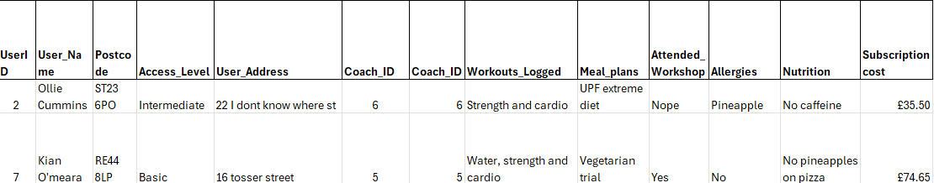
This is the dataset for unnormalised form (UNF) because it contains non-atomic data and repeating groups within single fields. For example, the user_name column stores both first name and surname together, which means it does not contain a single atomic value. Workouts_logged column contains multiple workouts in one cell, creaing a repeating group inside a single attribute. In addition, the tables mixes multiple entities such as user, coach, workouts, allergies and nutrition into one structure, leading to redundancy and data duplication. These issues mean the table does not meet the requirements of first normal form.

1NF
I made the data atomic in the first normal form

2NF

Table 1
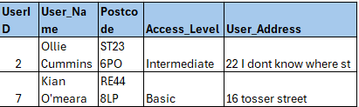

Table 2
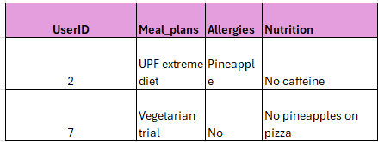

Table 3
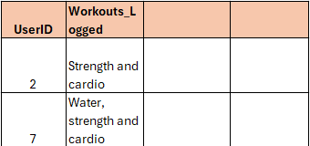

Table 4
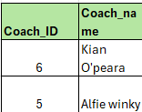
This design is in Second normal form (2NF) because it is already in 1NF and all non-key attributes depend on the whole key in their table. The repeating username details were removed from the order table and placed into separate tables so that client attributes depend only on userID. This removes partial dependency problems and reduces duplication across the database.

3NF

Table 1
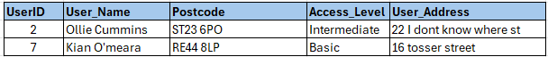

Table 2
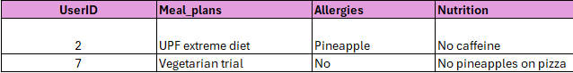

Table 3
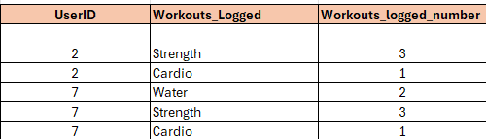

Table 4
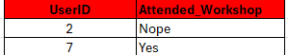

Table 5
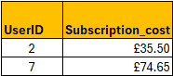

Table 6
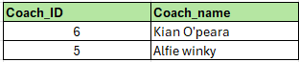

ERD (Entity Relationship Diagram)
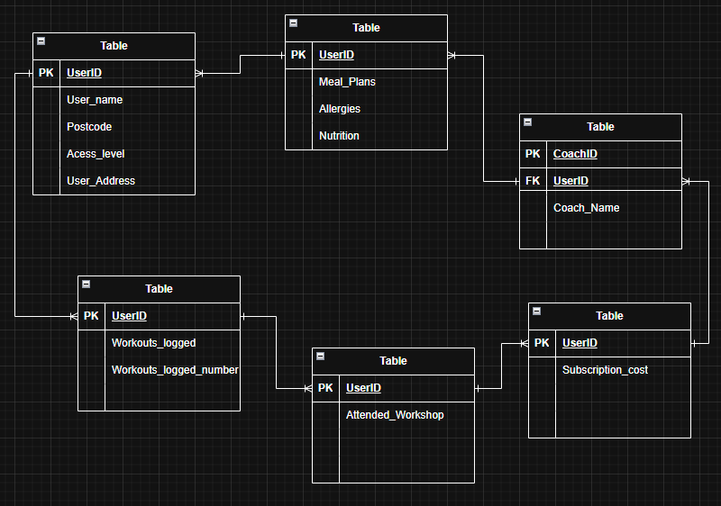

Data Dictionary

SQL

Data Types and Structures Summary

Reflection

